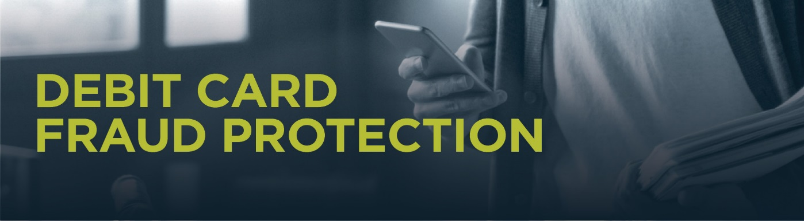

Dear valued cardholder,
Keeping your account safe and secure is our highest priority. We partner with SHAZAM, our debit card processor, to implement a fraud management solution powered by FICO® Falcon® to help protect your debit card against fraudulent activity.
We provide Text Fraud Alerts as part of our debit card protection program. You’ll receive text alerts when suspicious activity is detected on your <<FI NAME>> debit card. If you receive a “fraud alert,” reply Yes or No to confirm or deny the activity. If you reply No (the activity is fraudulent), you’ll quickly receive a follow up text to let you know that a SHAZAM fraud specialist will call you soon to help protect your account. We’ll also automatically block your debit card to prevent any additional fraudulent activity.
If you reply Yes (the activity was legitimate), you can continue to use your debit card as normal. If you don’t reply to the text, or your phone number is not a mobile number, we’ll attempt to reach you via automated voice call.
Text message alerts from: 72718
Automated phone calls from: 855-219-5399
Make sure to save these numbers to your contacts so you don’t miss any alerts. This added protection to your debit card is automatic and text message alerts are free. To ensure we can reach you promptly if fraudulent activity is suspected, we’ll need to have your current contact information on file including phone number(s) and address. Please contact us if you have any changes in this information. We’ll keep your information completely confidential.
If you have any questions, or ever see a suspicious transaction on your debit card, please call 573-782-3881. Always use caution when providing your debit card information and contact us immediately if you suspect your debit card has been stolen or compromised.
Thank you!
Community Point Bank

Important: We will never request card or account information via text, phone or email.

